YUM
# Source: AI Source: Provided by: [Data Path: Persons Table -> ID Column: 1, Name_En Column: Motasem Essam] -> From: [ChatGPT] on [1/26/2026]
YUM stands for Yellowdog Updater, Modified.
It is a package manager for Linux, specifically for Red Hat-based distributions like RedHat Enterprise Linux, CentOS, and Fedora.

What YUM Does
# Source: AI Source: Provided by: [Data Path: Persons Table -> ID Column: 1, Name_En Column: Motasem Essam] -> From: [ChatGPT] on [1/26/2026]
- Installs software packages
- Updates packages to newer versions
- Removes packages
- Automatically handles dependencies (libraries your software needs)

Common YUM Commands
# Source: AI Source: Provided by: [Data Path: Persons Table -> ID Column: 1, Name_En Column: Motasem Essam] -> From: [ChatGPT] on [1/26/2026]
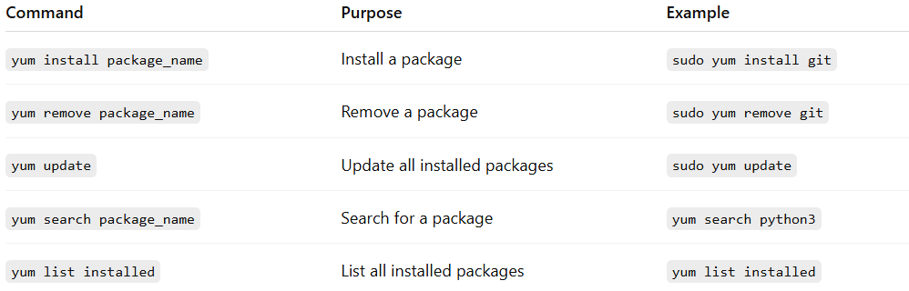
Command | Purpose | Example
yum install package_name | Install a package | sudo yum install git
yum remove package_name | Remove a package | sudo yum remove git
yum update | Update all installed packages | sudo yum update
yum search package_name | Search for a package | yum search python3
yum list installed | List all installed packages | yum list installed

Key Points
# Source: AI Source: Provided by: [Data Path: Persons Table -> ID Column: 1, Name_En Column: Motasem Essam] -> From: [ChatGPT] on [1/26/2026]
- YUM uses RPM packages (.rpm) to manage software.
- It automatically resolves dependencies, so you don’t have to install libraries manually.
- Mostly used on RedHat-based Linux, unlike apt which is for Debian-based Linux.

✅ Summary:
# Source: AI Source: Provided by: [Data Path: Persons Table -> ID Column: 1, Name_En Column: Motasem Essam] -> From: [ChatGPT] on [1/26/2026]
YUM is the system-level package manager for RedHat Linux that installs, updates, and manages software system-wide.

